Website design

All pages should have

Logo at the top left. Address on the right (B-168 Radhakrishna Park, Sahajanad Road, Near PF office Akota.)

Menu bar under the logo

Menu bar includes - Home, About US, Photo Gallery, Contact US, Owners Bio

Home page -

Under the menu bar - Subtitles in large font sizes

“Welcome to our Website”

Photo of the gym building.

“Your guide to health and fitness”

“Akota’s favourite gym”

“From weight loss to muscle training. Body sculpting to stamina enhancement. Weight gain to aerobics and yoga - We have got you covered.”

“Call us at (0265) 2342344”

“Or Google BodyKraft Gym”

About Us -

Bodykraft gym was established in 2000. It was conceived by Martial arts Police instructor Donald Melville. Initially the gym was to be solely utilized for his police trainees. However, since this was the only gym in the vicinity, people were impatiently eager to avail its facilities. This persuaded Donald to oblige.

To know more about Instructor Donald Melville, Click HERE..

Today 16 years later, Bodykraft gym has flourished and continues to outshine. The imminent success of the gym has made several expansions possible. From a singe section, Bodykraft gym now offers three exercise sections with various gym equipments.

The gym emphasizes the use of manual equipments.

We are always there to guide you towards fitness with a reliable trainer on the floor.

From weight loss to muscle training. Body sculpting to stamina enhancement. Weight gain to aerobics - We have got you covered with the best price in town!

Timings

The gym is open from Monday to Saturday. We have two unisex batches and two batches for ladies.

The timings of the batches are as follows

|  |  |
| --- | --- |
| 6:15 to 9:30 AM | Unisex batch (Combined for gents and ladies) |
| 5:00 to 9:30 PM | Unisex batch (Combined for gents and ladies) |
|  |  |
| 11:00 to 12: 30 Noon | Ladies Batch |
| 2:00 to 4:00 PM | Ladies Batch |

*Note - Males are not allowed to enter the gym premises during the specified ladies batch

Photo Gallery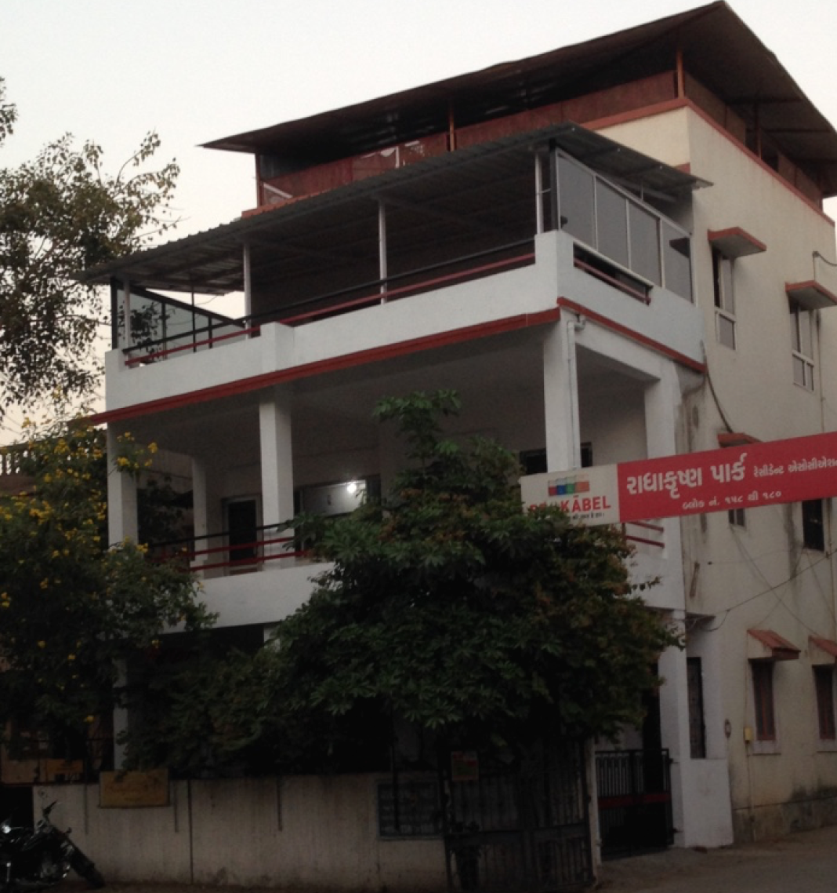

Contact Us

Google maps location

Bodykraft gym is located at -

B-168 Radhakrishna Park, Sahajanad Road, Near PF office Akota.

Please call us on (0265) 2342344

“Welcome to our Website”

Photo of the gym building.

“Your guide to health and fitness”

“Akota’s favourite gym”

“From weight loss to muscle training. Body sculpting to stamina enhancement. Weight gain to aerobics and yoga - We have got you covered.”

“Call us at (0265) 2342344”

“Or Google BodyKraft Gym”

Owner’s Bio

Donald Melville has coaching experience of 40 years in martial arts. He has trained in China and Hong Kong under grand master Leung Ting - International - Wing Tsun Martial Arts Association, an organization in which Bruce Lee was a student. He has also trained in Germany with the Special police squads, GSG-9 and SEK forces under Sifu Salih Avci. He was awarded the best their instructor and life time achievement award by the Government of Gujarat in 2003.

Donald is specifically trained in coaching the armed forces. He has coached and examine the IPS officer trainees at the National Police academy - Hyderabad, Border Security Force - Srinagar and the Special Task Force and the commando unit in Tamil Nadu.

He has been coaching the Gujarat Police for the last 22 years. Donald assisted in the formation and training of the Vadodara police - Special combat unit, under the supervision of Police commissioner Rakesh Astana.

He has also conducted seminars internationally.

Donald is associated with the Bollywood film industry and has choreographed action sequences for six films!